Photograph of B Squadron taken at Boiry 1940
LEFT HALF
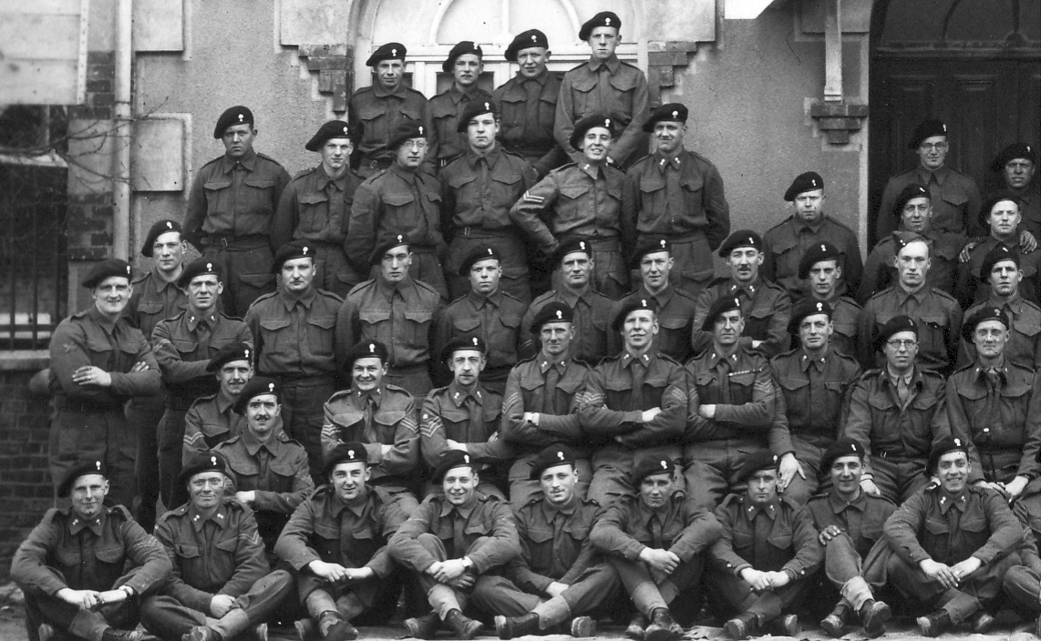
Cpl later Sgt Johnny C Finlayson
Cpl later Sgt Charlie Foley
Tpr Robson
Tpr Jimmy McPherson
L/Cpl Jock Gordon
Cpl “Safety” Fraser
Sgt Jake Clark
Staff Sgt Bill Miller
Sgt Eddie Christie
Sgt Andrew “Piper” Wilson
Sgt Davy Henderson
Sgt Ernie Leeper
Lt Ian Pittman
Major Wattie McCulloch
Tpr Charlie Borthwick
L/Cpl Sandy Clarke
Cpl Arthur Symington
Tpr Sid Willis
Cpl “Spud” Murphy
Cpl Tom Bowie
L/Cpl Kenny Roberts
L/Cpl John Stevenson
Tpr Bobby Kerr
Tpr Gordon Fortune
Tpr Coe
Cpl Finney
Cpl Munro
Tpr V Mee
Bill Deans

