Photograph of B Squadron taken at Boiry 1940
RIGHT HALF
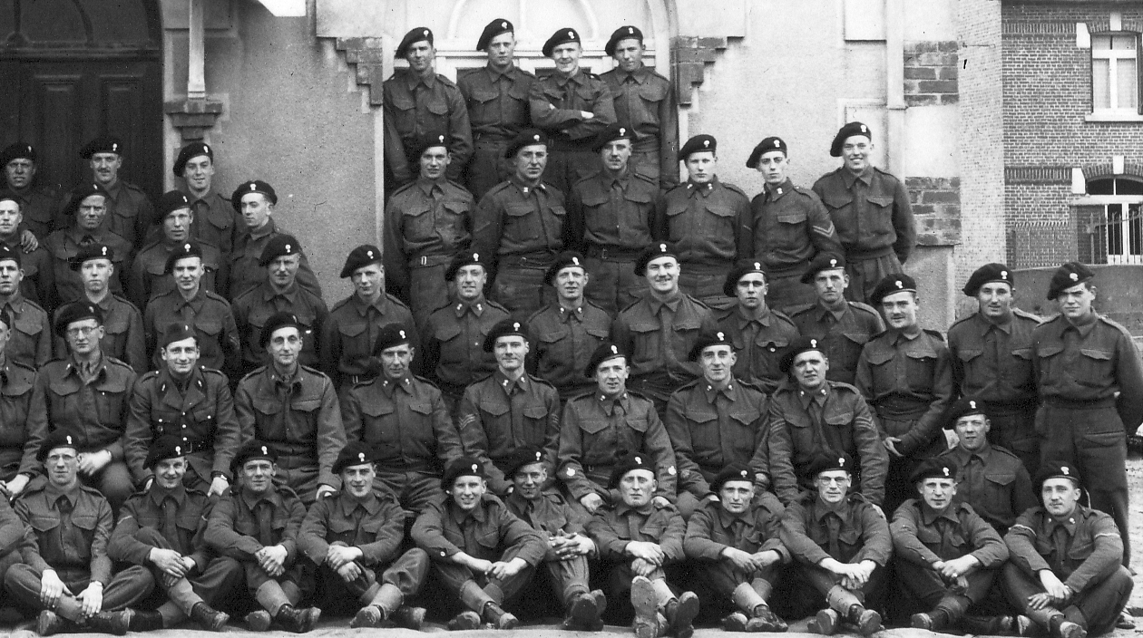
Tpr Arthur Tyson
Tpr Kennedy
Tpr “Andy” Anderson
L/Cpl Johnny Burkhart
Capt Pat Turcan
CDT “Toots” Thouvenin
Lt Baird
Sqdn Sgt Major Alfie Upton
Sgt Ian Grant
TSM Tommy Kerr
TSM Jimmy Hogarth
Sgt “Stomewall” Jackson
Tpr Alec Malvaney
Tpr Paddy Cox
Tpr Tabs Clitheroe
Cpl Alec Hogg
L/Cpl Willie Laing
Tpr Rab Whyte
Tpr Charlie McKinney
Tpr Snowy White
Tpr John McKenzie
L/Cpl Jimmy Jack
Tpr Wattie Robertson
TprKenny McCarten
Tpr Ian Bathgate
Cpl Brimson
Tpr John McLeod
Tpr Mick Shanley
Tpr Milliken
Cpl George
Prior
Tpr Blues
L/Cpl CharlieWhite
Tpr George Faulkner
L/Cpl W.G. Campbell

