Photograph of C Squadron
LEFT HALF
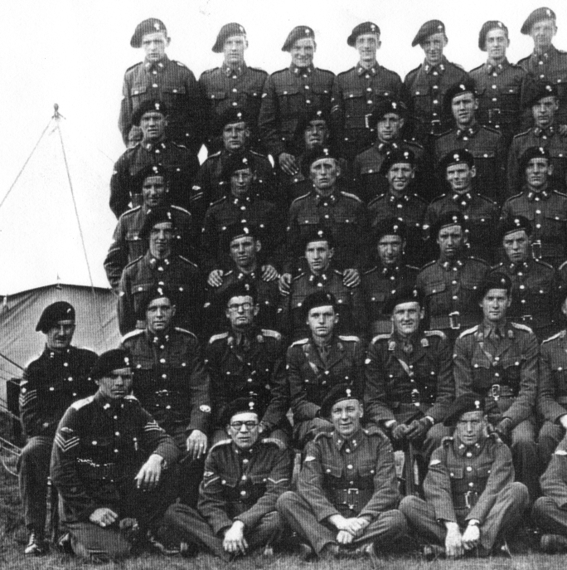
Kenny Bain
Cpl Bill Ronald
Mick Shanley
Poss: Tpr Gavin Mollison
Cpl Larry Aspey
Bill Bertram
Lt Nigel Baird
SSM Jimmy King
Staff Sergeant Hughie Ross
Sgt Dave Arbuthnot
Tpr Alf Black

