Photograph of C Squadron
RIGHT HALF
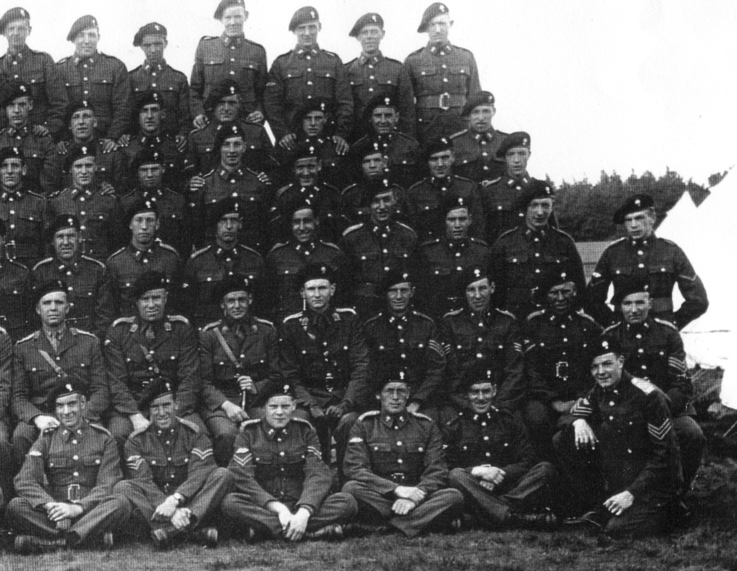
Slim Walker
Beattie
Cpl Sandy Peacock
Aspey
L/Cpl Ian McDougall
Capt later Major Dove-Wilson
Poss: Lt later Capt Joe Hume
Tony Chambers
SgtBert Christie
Poss: Sgt Curly Fairholm
Sgt later TSM Rab Stewart

